

PULSENET REGIONAL DATABASE/SERVER REQUIREMENTS INFO SHEET

I) Hardware and Software Requirements
Hardware:
Application Server
Database Server
Admin Workstation
Client Workstation

Software:
BioNumerics Server Software (one for each server)
BioNumerics Client Software (one for each server and one for each client)
SQL or Oracle Software (one for the database server only)

II) Hardware and Software Configuration
Servers:
Application Server:
Windows Server Operating System
BioNumerics Server Software
BioNumerics Client Software
Database Server:
Windows Server Operating System
BioNumerics Server Software
BioNumerics Client Software
SQL or Oracle

Clients:
Admin:
Windows Professional Operating System
BioNumerics Client Software
PulseNet Admin Scripts
Client:
Windows Professional Operating System
BioNumerics Client Software
PulseNet Client Scripts

*Note: Gel Compar Client Software can be substituted for BioNumerics Client Software
-The costs for setting up a BioNumerics Online Server and Regional/National Database includes, but are not limited to, the servers and workstations, as well as the operating systems and the BioNumerics server and client software. The hardware costs will depend on current market prices, specifications and the manufacturer of the hardware. The software costs will depend on the BioNumerics version and the number of licenses needed.
-The BioNumerics Online Server will need to be accessible to the BioNumerics clients via the Internet. Therefore, internet connectivity costs should be taken into consideration when planning costs.

III) Regional Database Personnel Requirements
Please note that one person may be able to perform more than one of the tasks mentioned below.
- Database managers (for each organism)
- Supervisor/coordinator of database managers
- QA/QC manager responsible for the certification and proficiency program
- Network administrator/engineer support, responsible for the installation, operation and maintenance of the BioNumerics applications on the servers and workstations
-The costs are associated with compensation for database managers, supervisors, QA/QC manager and network administration/engineer support.

IV) Regional Database Activity
- Regional reference laboratories (PulseNet participating laboratory): analyze and upload isolates from local client databases; and download, query and compare isolates submitted to the regional database using BioNumerics or Gel Compar software.
- Database manager: analyzes and uploads isolates for participants who are not analysis certified or who do not have the required resources; verify the accuracy of the bandmarkings of the uploaded isolates; assigns pattern names to isolates; maintains the integrity of the databases; identifies clusters and potential outbreaks; assists epidemiologists in outbreak investigations; provides classroom and on-site instructions and training for BioNumerics training; and attends Update Meetings.
- Supervisor/coordinator of database managers: supervises database managers in their daily work, as well as prepares and presents database team-related information and documentation, as requested.
- QA/QC manager: works with regional/national laboratories to prepare and distribute certification sets; evaluates gel and analysis certification submitted by laboratorians; works with regional/national laboratories to prepare and distribute proficiency sets; evaluates proficiency of gel and analysis; prepares updates and distributes quality control documentation.
- Network administrator/engineer support: responsible for the installation, operation and maintenance of the BioNumerics applications on the servers and workstations; provides access to the regional database; provides access to a discussion forum which is accessible by all regional PulseNet participants (including epidemiologists) through the Internet, and that would serve as the central communication tool for distributing information relevant to current clusters and outbreaks; as well as provides daily troubleshooting support for PulseNet participants.

V) Regional Data Management Flowchart (Example: PulseNet Latin America)

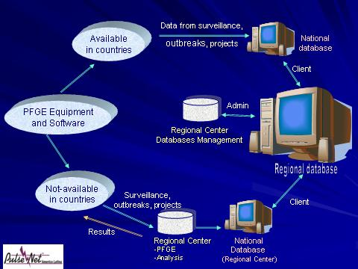

Please contact Ahmed ElSedawy at (404) 639-3977 or frx5@cdc.gov for further information

